Engine Architecture
Done in C++
Michael Pansegrauw
2021
Table of Contents
Introduction 2
Research 2
Unity 2
History 2
Underlying technology 2
Capabilities and Features 3
Game development approach 3
Engine Architecture 4
Design 5
Justification 5
Engine feature list 5
API feature list 5
Engine Architecture 6
Referencing 7

Introduction

Research

Unity

History
Unity is a multiplatform game engine that supports almost every major platform available currently, including android, iOS, web, PC, and most consoles (Unity Technologies, 2021). Unity was first released in June of 2005 with a few features and lots of documentation to assist developers in the use of Unity 1.0 on Mac. Version 1.1 brought support for windows, as a game platform, and external C++ plugins (Haas, n.d.). This marked the start of Unity and made them a small game engine that only a few hobbyists made use of.
Unity 2.0 was released and allowed for support for Microsoft DirectX, which gave a boost to performance, and improved web player compatibility for all platforms at the time. Unity noticed a need for windows support for their editor and this was added with Unity 2.5 in 2009 (Haas, n.d.).
The next major Unity update came with Unity 3.0. This brought a lot of newer features including an editor unification, Beast lightmapping, deferred rendering, FMOD audio filters, debugging, and Umbra occlusion culling. With Unity brining int support for these features they proved that they were determined to stick around (Haas, n.d.). By this point Unity had about 200 000 registered unity developers.
In June of 2012, Unity 4 brought Mecanim animation technology, Flash deployment, Linux publishing preview, and the Shuriken particle system to the table in an early access release. The final release came in November of 2012 along with official support for 2D games and sprites (Haas, n.d.).
Unity 5 was released in March of 2017 and brought the biggest update to Unity so far, including Physaically-based standard shader, real-time global illumination built in, a revamped audio mixer, HDR reflection probes, PhysX 3.3, major updates to the animation system, and WebGL preview. This update is the update that made Unity a real competitor for some other game engine markets, such as Unreal engine.

Underlying technology

Deferred-rendering
Deferred rending is a rendering technique that allows for a higher performance when dealing with many light sources. Unit makes use of this to optimise use cases where thousands of light sources may be present in a scene, and it greatly improves performance in these scenarios. The process involves delaying the calculations of lights to a later stage once all the geometry is loaded. The alternative to this so forward rendering which is used for fewer lights in cases where real-time lighting is more important and on mobile phones where deferred rendering takes more of a hit on performance. This is because deferred rendering makes use of more memory than forward rendering.

Mechanim animation
Mechanim animation is Unity’s solution to make animations easier and to provide an easy workflow for animations. It Provides animation retargeting, which is the ability to apply animations to multiple models, a simplified for aligning animation clips, allowing for previews of animations and animation transitions, allowing animation of different body parts with different logic, and allowing developers to manage complex animation interactions with a visual programming tool. This allows for developers to create complex animation interactions with a simple and effective workflow (Unity Technologies, 2020).

PhysX 3.3
Unity makes use of a build in physics system that works with NVidias PhysX system. The Nvidia PhysX system is a physics simulation system that is focused on delivering realistic physics interactions. Making use of this allows Unity to make use of an already great physics system and put more focus on integration of the system rather than development of the system.

Real-time global illumination
Unity has the capacity to have real-time global illumination. This is useful for scenes that have a slow change of light in a large scene where light has a high visual impact on the scene, such as the sun moving across the sky. The light system manages how light bounces off surfaces in a scene and provides indirect light to other objects in a scene. This gives scenes a much more realistic lighting effect (Unity Technologies, 2020).

Capabilities and Features

Unity Cloud build
Unity Cloud build is a part of the unity teams service and it provides a method of building unity projects on Unity’s servers to save time and hardware resources for developers. Unity has made this process to automate part of the process to assist developers (Unity Technologies, 2020).

Asset store
The asset store is a places where developers can find a host of assets, plugins, and other Unity Technologies. These products can be gotten for a variety of process all the way down to free. In the store you can also narrow down what you are looking for by selecting the desired group of asset packages and searching using the search bar. The developer can then make use of these assets in their own projects.

Fast compile times.
Unity offers fast compile times thanks to the majority of the engine being coded in C++. C++ is an incredibly fast language with a fast compile time due to the fact that C++ is such a low level programming language. This compile time can even be eliminated completely thanks to Unity’s Cloud build service.

Multiplatform publishing
The Unity game engine was designed to be a game engine that empowers game developers to make what ever they want. This includes when developers want to make games for multiple platforms so, the Unity game engine is built to be able to support compiling games for most consoles, VR systems, smart phones, Mac, iOS, and Windows.

Game development approach
When a user opens the Unity editor, they are given a blank canvas to work with. Unity focused on giving its developers the opportunity to make almost anything. This means the developer is faced with making all the controls and interactions that will be done in the game. Developers will have to make use of multiple work flows with in unity to make a full game, such as the asset making work flow and making use of the MonoBehavior scripting to its full potential.

Engine Architecture
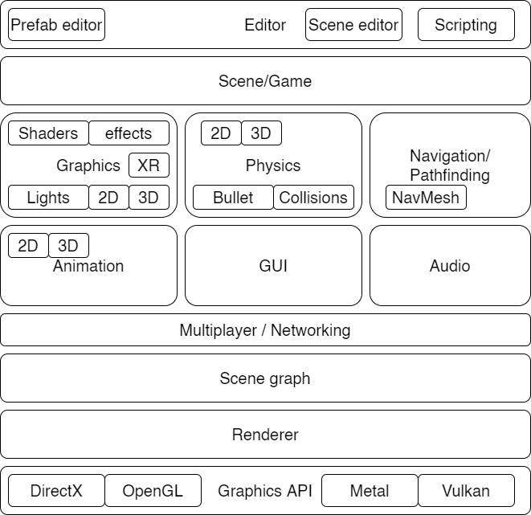

Design

Justification
Unity is the chosen game engine to be based off. This is because Unity is an engine that caters a lot more to beginners and making game development available to everyone. Unity is a strong game engine to follow and they have been hugely successful in what they have done with their engine. It is made in C++ and allows for use of the OpenGL API. This can be learned from to create an engine in C++ that focusses on the use of OpenGL

Engine feature list
External level editor – This will make creating levels and designing the game world easier by using an external level editor to create levels and giving the developer helpful tools to use when creating levels.
Sky box – The game world will have support for a Skybox to be loaded to create more of an immersive experience for the players.
Support for FBX models – The game engine will support loading of FBX models so that the developer can load in models from a multitude of 3D modelling software.
Multiple textures – The engine will support multiple textures so that the game will be able to create unique worlds that aren’t limited by the software they are using.

API feature list

GLFW
GLFW is a utility library that will be used to create and manage windows and OpenGL contexts. This will also be used to manage the input from the user.

OpenGL
OpenGL is the choice API that will be used for rendering 2D and 3D vector graphics for the engine and it will be the main backbone for the engine.

UI Library
There will be a need for a UI library for the editor and perhaps for some in-game UI elements but there has yet to be a decision for the libraries chosen. The library will need to support generating a window, buttons, text, loading bars, and icons or images.

Engine Architecture
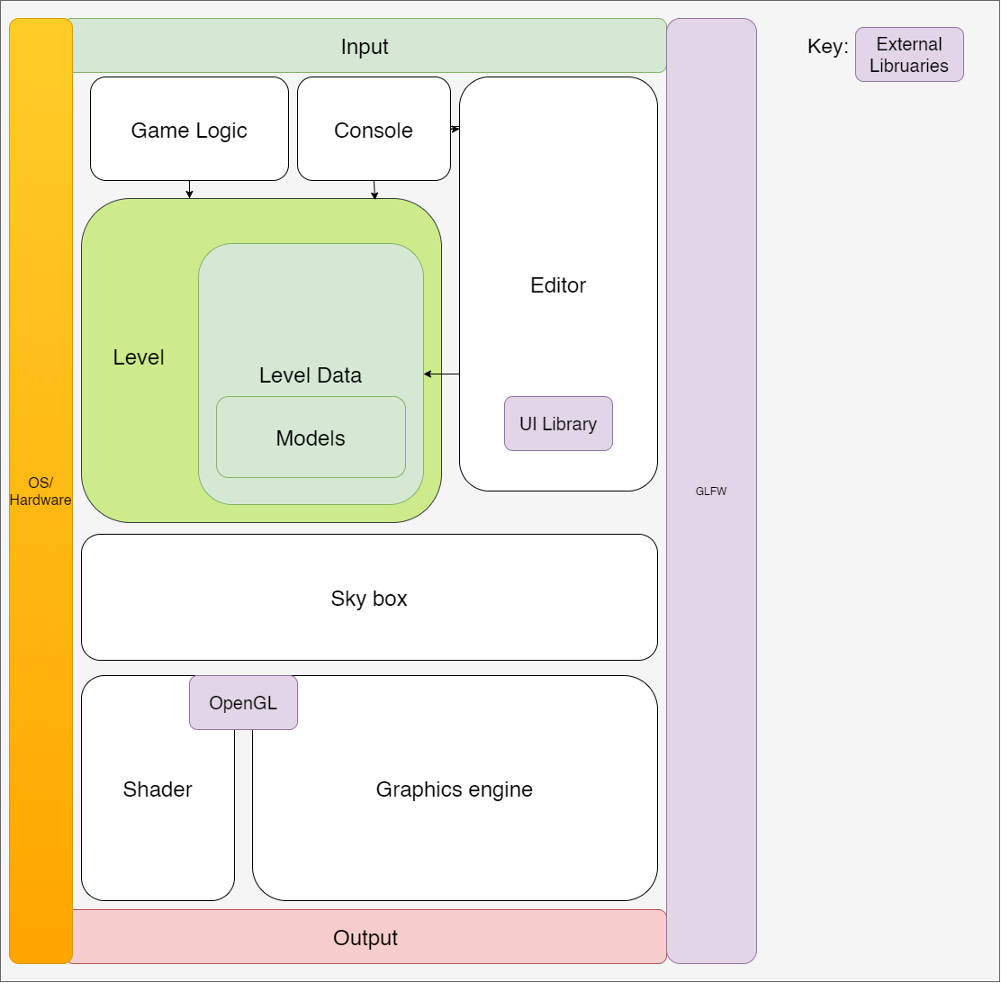

Referencing
Brodkin, J. (2013). How Unity3D Became a Game-Development Beast. [online] Dice Insights. Available at: https://insights.dice.com/2013/06/03/how-unity3d-become-a-game-development-beast/ [Accessed 25 Sep. 2021].
Daosheng Mu (2012). Design your 3d game engine. [online] Slideshare.net. Available at: https://www.slideshare.net/ellisonmu/design-your-3d-game-engine [Accessed 25 Sep. 2021].
Haas, J. (n.d.). A History of the Unity Game Engine An Interactive Qualifying Project Submitted to the Faculty of WORCESTER POLYTECHNIC INSTITUTE in partial fulfillment of the requirements for graduation. [online] Available at: http://web.wpi.edu/Pubs/E-project/Available/E-project-030614-143124/unrestricted/Haas_IQP_Final.pdf.
Learnopengl.com. (2020). LearnOpenGL - Deferred Shading. [online] Available at: https://learnopengl.com/Advanced-Lighting/Deferred-Shading [Accessed 25 Sep. 2021].
Peckham, E. (2019). How Unity built the world’s most popular game engine. [online] TechCrunch. Available at: https://techcrunch.com/2019/10/17/how-unity-built-the-worlds-most-popular-game-engine/ [Accessed 20 Sep. 2021].
Powers, K.W. (2021). Introduction to Physics in Unity - Level Up Coding. [online] Medium. Available at: https://levelup.gitconnected.com/introduction-to-physics-in-unity-1113ff12397b [Accessed 28 Sep. 2021].
Unity Technologies (2020a). Unity - Manual: Realtime Global Illumination using Enlighten (deprecated). [online] Unity3d.com. Available at: https://docs.unity3d.com/Manual/realtime-gi-using-enlighten.html [Accessed 28 Sep. 2021].
Unity Technologies (2020b). Unity - Manual: Realtime Global Illumination using Enlighten (deprecated). [online] Unity3d.com. Available at: https://docs.unity3d.com/Manual/realtime-gi-using-enlighten.html [Accessed 28 Sep. 2021].
Unity Technologies (2020c). Unity - Manual: Supported platforms. [online] Unity3d.com. Available at: https://docs.unity3d.com/Manual/UnityCloudBuildSupportedPlatforms.html [Accessed 25 Sep. 2021].
Unity Technologies (2020d). Unity - Manual: Unity Cloud Build. [online] Unity3d.com. Available at: https://docs.unity3d.com/Manual/UnityCloudBuild.html [Accessed 28 Sep. 2021].
Unity Technologies (2020e). Unity - Manual: Using the Asset Store. [online] Unity.cn. Available at: https://docs.unity.cn/2020.1/Documentation/Manual/AssetStore.html [Accessed 28 Sep. 2021].
Unity Technologies (2021). Multiplatform | Unity. [online] Unity. Available at: https://unity.com/features/multiplatform [Accessed 25 Sep. 2021].

